LAB 01
Report
LAB TASK:
Index.html:
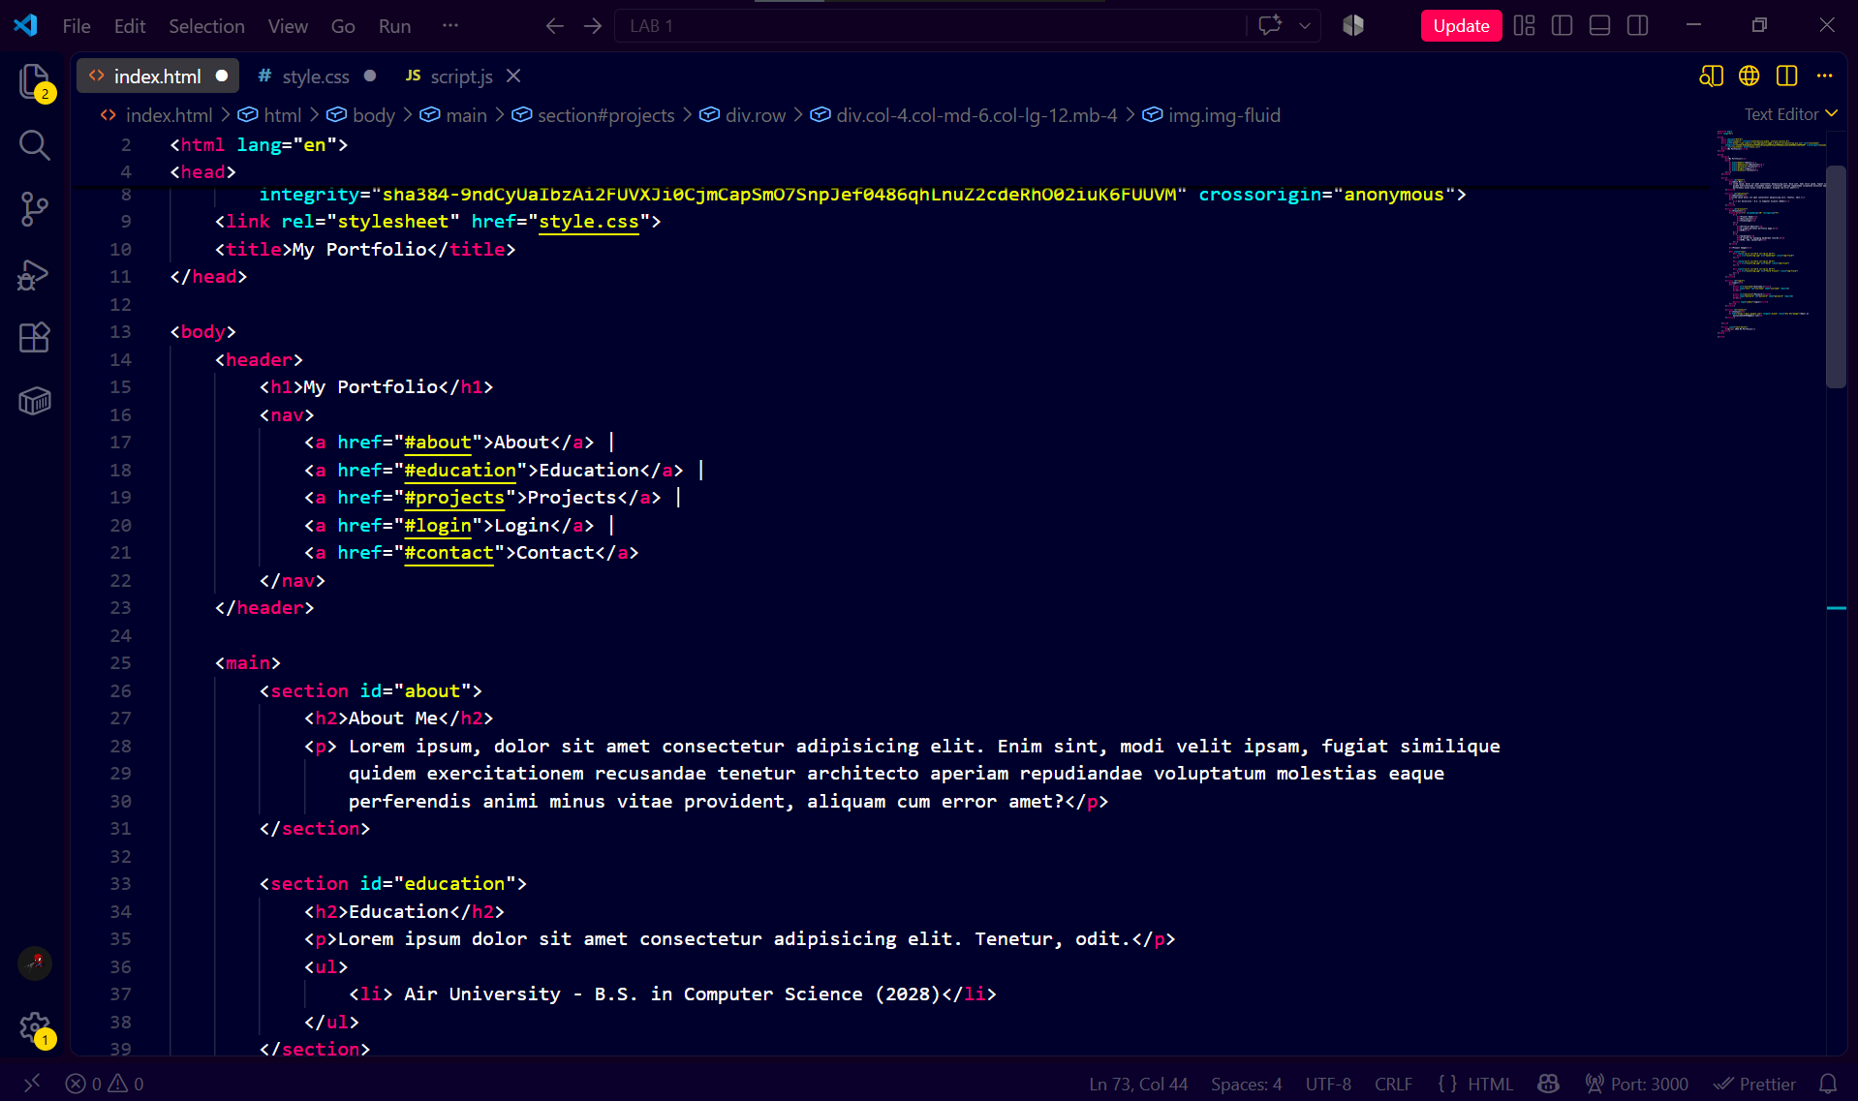
Style.css:
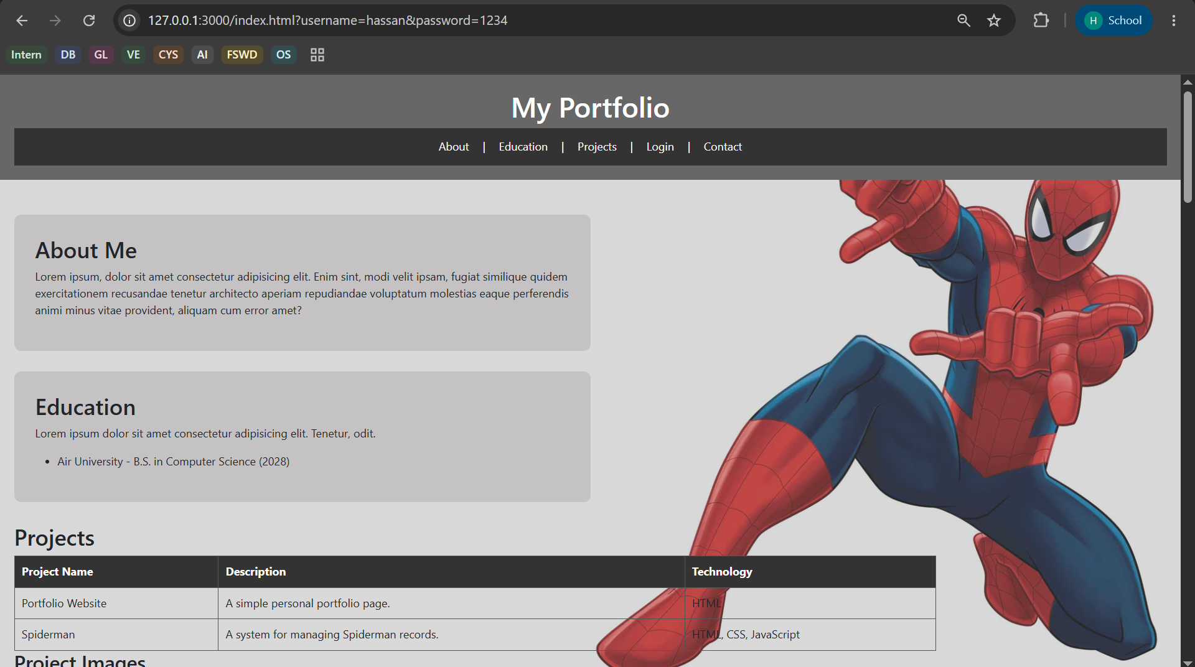
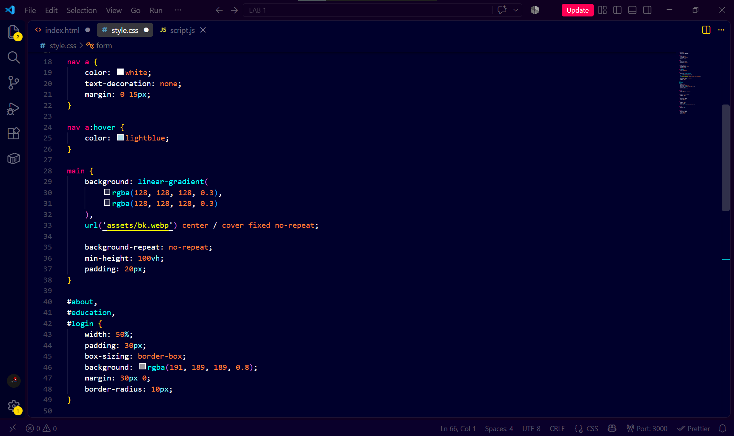
Output:

Responsive Grid Layout Task:
Explanation:
Bootstrap divides a webpage into a 12-column grid. We decide how many of these columns an element should occupy at different screen sizes. In my code I have used;
class="col-4 col-md-6 col-lg-12"
This means that on small screens like mobile phones 4 columns out of 12 (col-4) will be used by one card (image), one medium screens like tablets 6 columns out of 12 (col-md-6) will be used and for large screens like desktops 12 columns out of 12 (col-lg-12) will be used. And to change this process we just have to adjust the allocated size for each card.
Output:
Desktop:
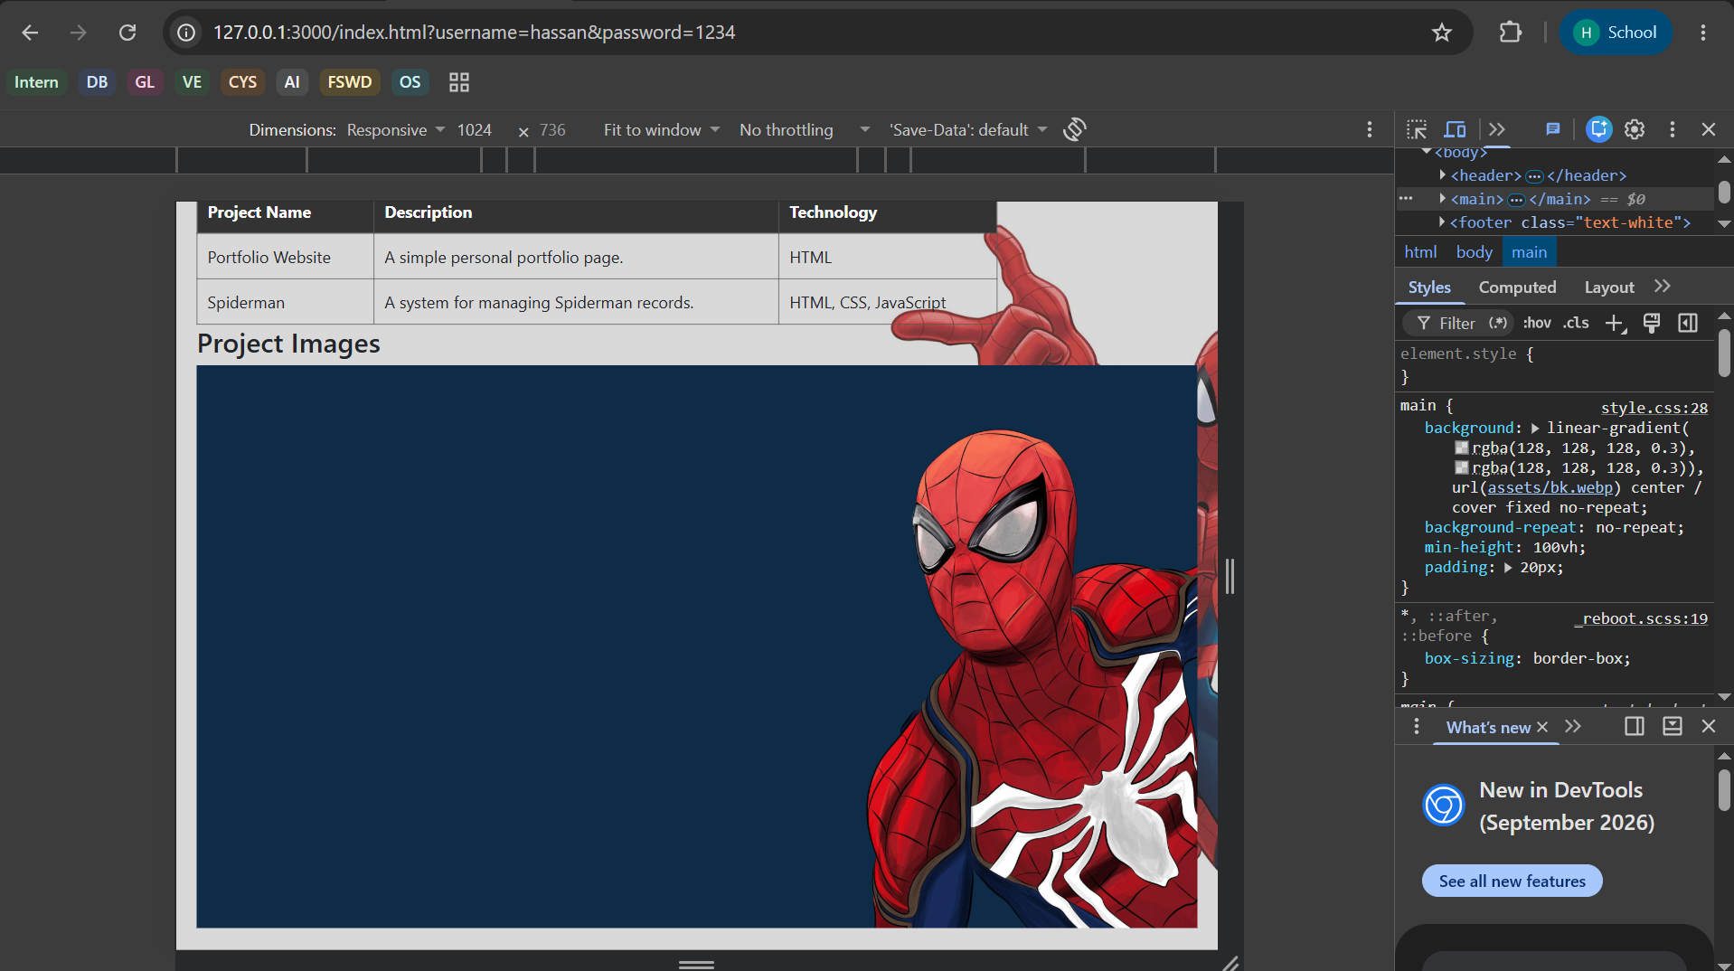
Tablet Screen:
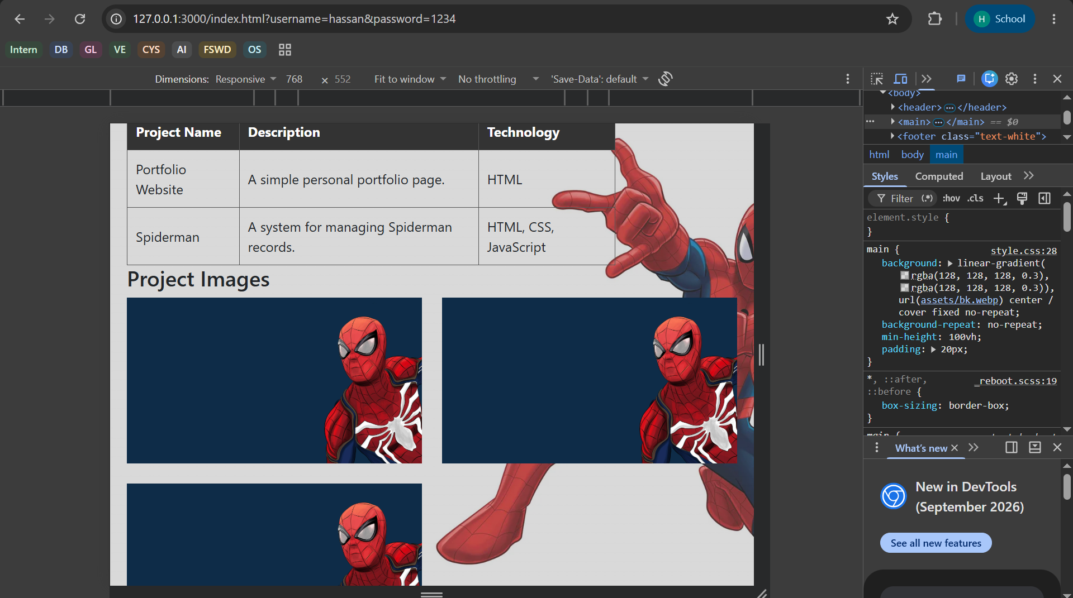
Mobile Screens:
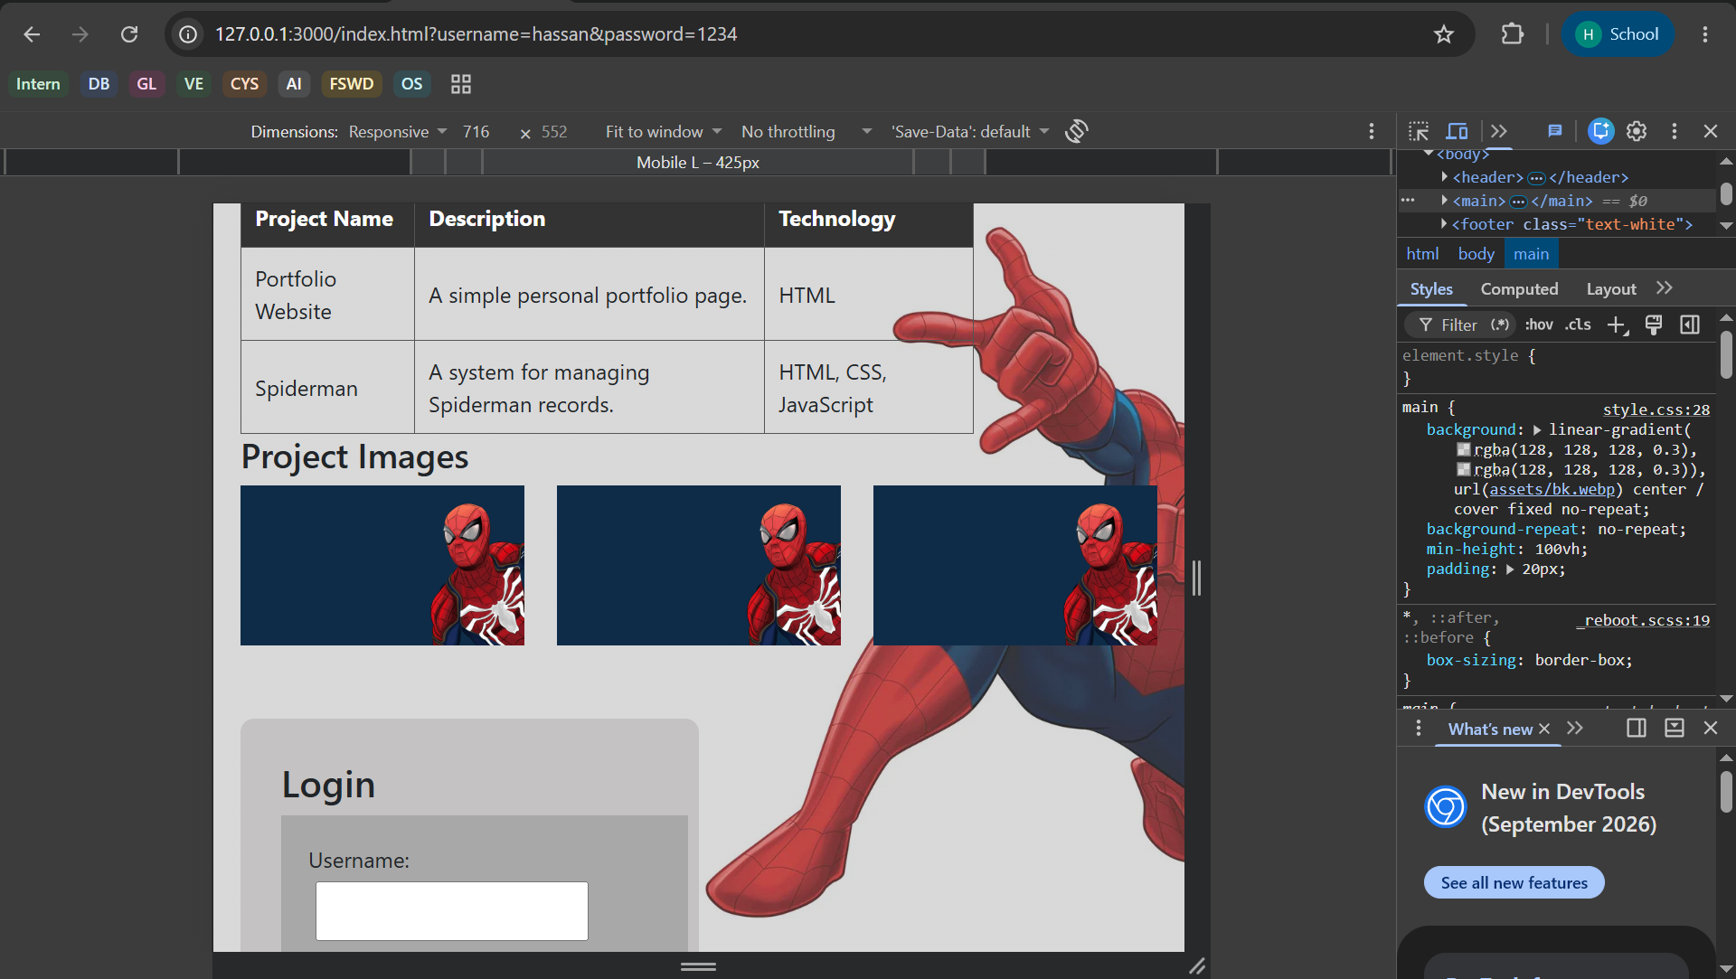

Home Task:
Index.html:
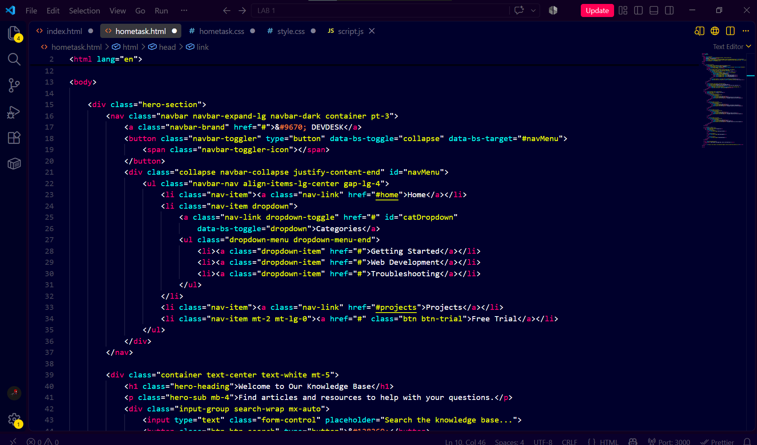
Style.css:
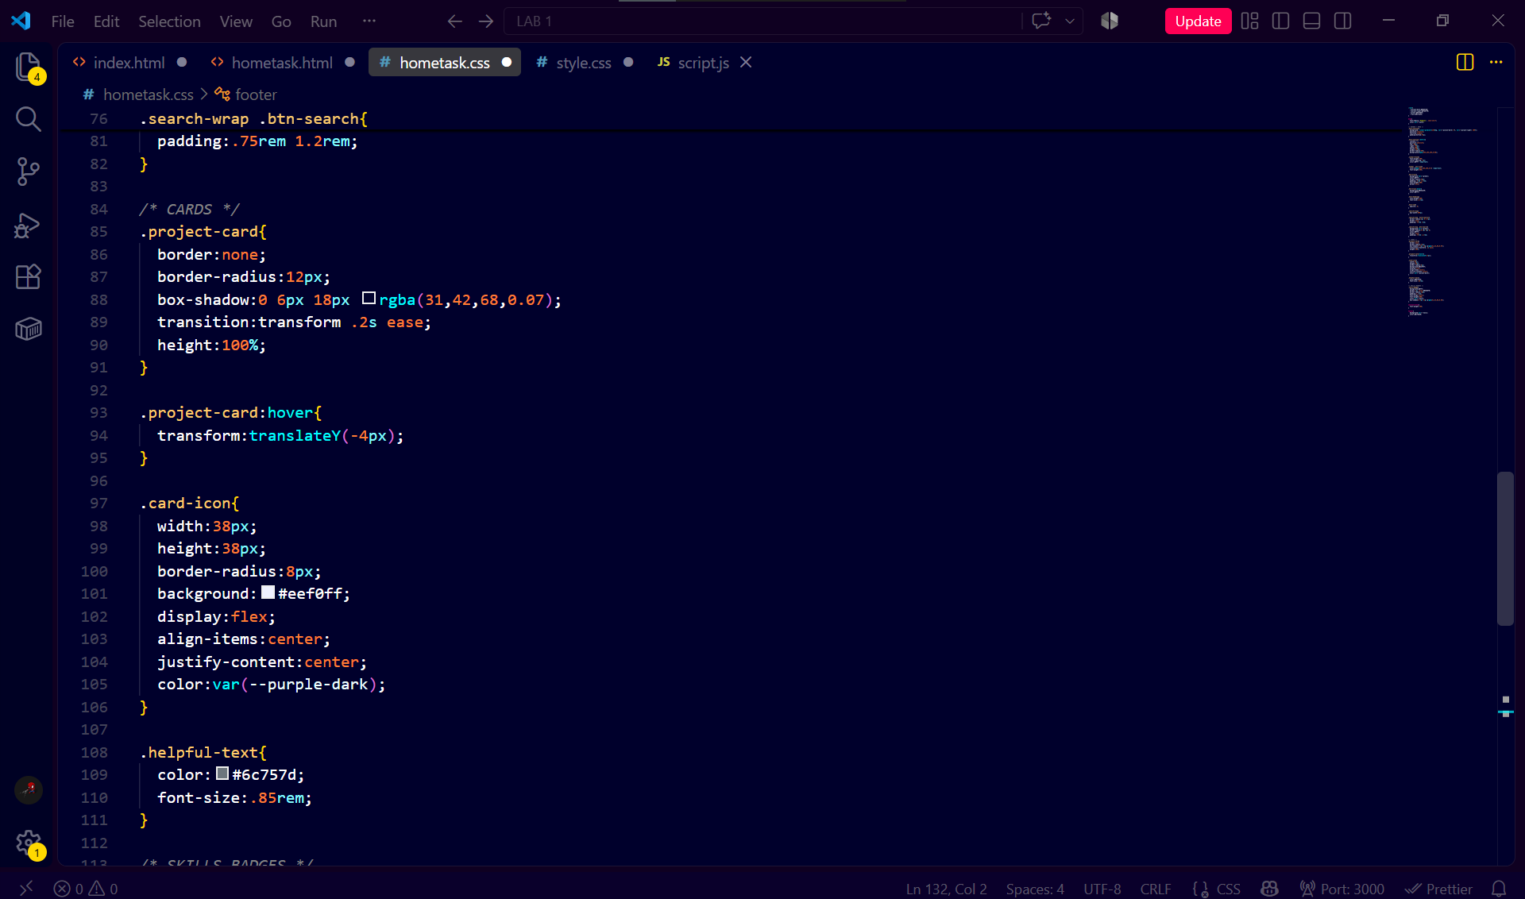
Output:
